Obesity Level Prediction Using Machine Learning and Lifestyle Factors

Caroline Iheanacho and Primrose Mncube

A Report Submitted in Partial Fulfilment
of the requirements for the
Degree of
BSc in Computing in IT (4th year)



May 2026

Supervisor:
Dr. Muhammad Iqbal

Abstract:
This research analyses the machine learning classification models used to predict obesity levels based on demographic, behavioural, and lifestyle factors. The study addresses the basic methodological issues in multiclass classification, feature selection, and model optimisation, as well as giving important insights into the factors that influence obesity classification.

The study uses the Obesity dataset and the CRISP-DM framework to guide the data analytics process, which includes data understanding, preparation, modelling, and evaluation. Three classification algorithms were used, decision tree, K-nearest neighbours (KNN), and Random Forest. These models were selected to represent different types of learning approaches, including tree-based, distance-based, and ensemble methods. To improve model performance, hyperparameter tuning was done using GridSearchCV, with weighted F1-score used as the key evaluation metric due to the problem's multiclass nature.

The research makes three main contributions. First, it evaluates the comparative performance of different classification algorithms in predicting obesity levels and identifies the most effective model for this task. Second, it examines the impact of hyperparameter tuning on model performance, demonstrating how optimisation improves classification accuracy and generalisation. Third, the study develops a prototype Obesity Risk Prediction Tool, illustrating how predictive models can be applied in a practical decision-support context for health awareness.

The findings give evidence for how suitable machine learning models for obesity classification, highlight the importance of model tuning, and highlight the potential of data-driven approaches in supporting the early detection of obesity risks. These findings help improve both academic understanding and practical applications in health-related predictive analytics.

Introduction
Obesity is a serious global public health concern, with growing rates in both developed and developing countries. It is associated with many different kinds of chronic health issues, including cardiovascular disease, diabetes, and reduced life expectancy. Obesity's complexity comes from the interaction of multiple factors, including demographic factors, eating habits, physical activity, and behavioural patterns. This complexity makes obesity an important area for data-driven analysis and predictive modelling.(World Health Organization, 2025)

Recent advances in data analytics and machine learning have enabled researchers to analyse large datasets and identify patterns that would have been difficult to identify using standard statistical methods. Decision Trees, K-Nearest Neighbours (KNN), and Random Forest are examples of machine learning classification algorithms that have been widely used in healthcare prediction applications due to the ability to handle non-linear relationships and complex feature interactions. These methods provide an opportunity to improve obesity classification and help in the early identification of those at risk. (Dritsas and Trigka, 2025)

The Obesity dataset used in this study contains demographic, behavioural, and lifestyle variables, allowing for a structured analysis of the factors that influence obesity levels. This research uses a machine learning approach to explore how these variables contribute to obesity classification and to analyse the effectiveness of different algorithms in predicting obesity categories. (archive.ics.uci.edu, 2019)

Problem statement

Despite the growing use of machine learning in healthcare analytics, there are still major challenges to using predictive models for obesity classification. Many current research studies are mainly concerned with model accuracy, without fully analysing the impact of model optimisation, feature selection, and algorithm comparison. Furthermore, there is often little discussion about how different classification models perform to one another when applied to the same dataset.

Another challenge is selecting appropriate evaluation metrics. In multiclass classification issues, such as obesity level prediction, focusing just on accuracy may not provide a complete picture of model performance. Precision, recall, and F1-score are more suitable metrics for assessing model performance across multiple classes. (Farhadpour et al. 2024)

In addition, much research lacks practical implementation. While predictive models are being developed, fewer research have shown how they might be turned into real-world applications that help decision-making and awareness. (“What Is Predictive Research and How Does It Work?”, 2026)
This research will address the gaps by comparing multiple classification models, by applying hyperparameter tuning to improve performance, and developing a prototype system to demonstrate practical applications. (Justus Akinlolu Ilemobayo et al. 2024)

The Aim and objectives
The main aim of this research is to develop and evaluate machine learning models for predicting obesity levels based on the demographic, behavioural and lifestyle factors.
To achieve this aims the research is guided by the following objective:
- To analyse and understand the obesity dataset using data analysis techniques.
- To prepare and process the data for machine learning models.
- To implement classification models such as Decision Tree, KNN, and Random Forest.
- To use hyperparameter tuning to improve model performance.
- To evaluate and compare models using appropriate metrics, such as accuracy, precision, recall, and F1 score.
- To create a prototype Obesity Risk Prediction Tool that shows the actual application of the models.

Research Questions

1. Which machine learning model provides the highest predictive performance for obesity classification?

2. How does hyperparameter tuning affect the performance of classification models?

3. Which lifestyle and behavioural factors are most important in predicting obesity levels?

4. How can predictive models be applied in a practical system for obesity risk awareness?

Methodology
Research Approach

Data Understanding

The dataset used in this project is the Obesity Dataset (ObesityDataSet_raw_and_data_sinthetic), which contains information related to individuals’ demographic characteristics, UCI (archive.ics.uci.edu, 2019)
The data understanding phase focuses on exploring and getting familiar with the dataset before building any machine learning models. At this stage, the goal is to understand what kind of data we are working with, identify patterns, and check for any issues that might affect the results later on.
The dataset used in this project contains information about individuals such as their age, gender, height, weight, eating habits, physical activity, and lifestyle choices.
From an initial inspection, it is clear that the dataset includes a mix of numerical values (such as age, height, and weight) and categorical variables (such as gender, smoking habits, and transportation type). The target variable, NObeyesdad, represents different obesity categories, which means this is a classification problem.
Understanding these variables is important because it helps identify which features may influence obesity levels and ensures the data is suitable for building predictive models.
Data Description
The dataset consists of several groups of variables:
- Demographic variables: Gender, Age
- Physical attributes: Height, Weight
- Eating habits:
  - FAVC (frequent consumption of high-calorie food)
  - FCVC (frequency of vegetable consumption)
  - NCP (number of main meals)
  - CAEC (consumption of food between meals)
  - CH2O (water consumption)
  - CALC (alcohol consumption)
- Lifestyle behaviours:
  - FAF (physical activity frequency)
  - TUE (technology usage time)
  - SMOKE (smoking habits)
  - SCC (calorie consumption monitoring)
- Family background:
  - family_history_with_overweight
- Transportation:
  - MTRANS
- Target variable:
  - NObeyesdad (obesity level category)

Target Variable Analysis
The target variable NObeyesdad represents different categories of obesity, making this a multi-class classification problem. We used a count plot to examine the different obesity categories
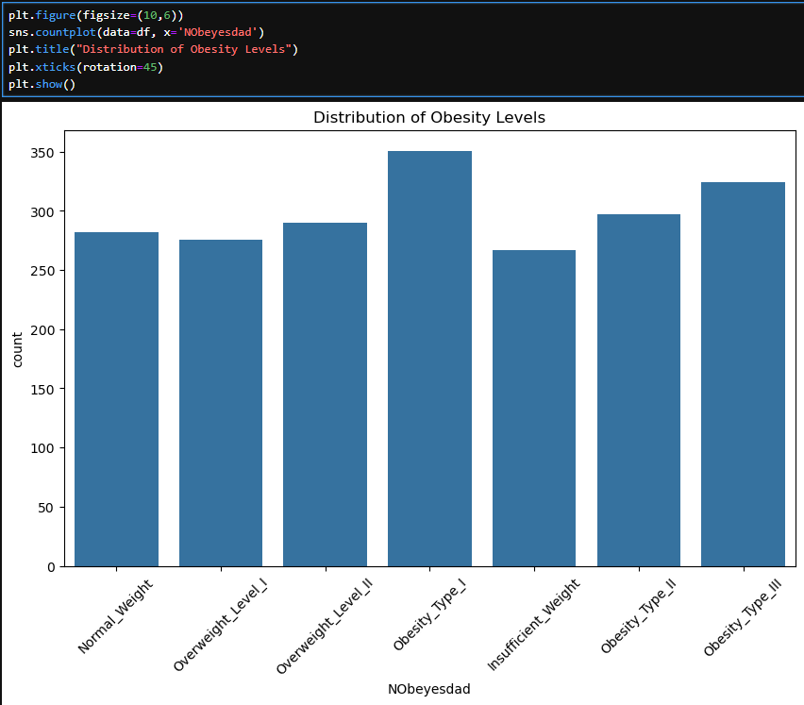
Fig 1: Distribution of obesity levels

Key Observations:
The dataset contains multiple obesity classes, including normal weight, overweight, and various obesity types. Some classes appear more than others.

Exploratory Data Analysis
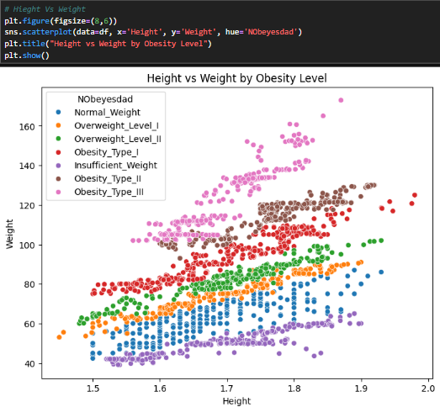
Fig 2:height vs weight scatterplot
Relationship between height and weight
We used a scatter plot to analyze the relationship between height and weight. From looking at the data is it evident that obesity categories are significantly more influenced by weight than by height. People are more likely to become obese as their weight increases, and this trend is rather constant across the dataset. In contrast, there is less variation in height between the various categories, therefore it is not as important for differentiating between them. Even though taller people tend to weigh more, the shift in the definition of obesity is actually driven by weight gain. Overall, data indicates that while height has a smaller and less obvious effect, weight is one of the most significant characteristics for predicting obesity levels.

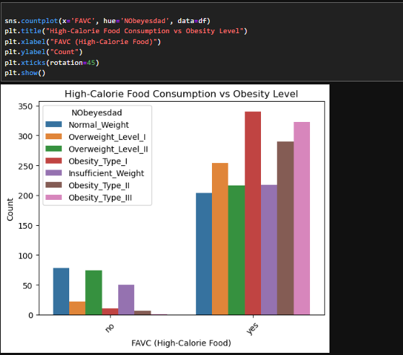
Fig 3: High calorie consumption vs obesity
The plot clearly demonstrates the connection between obesity levels and the use of high-calorie foods. People who regularly eat high-calorie foods (FAVC = yes) are significantly more likely to go into higher obesity categories than people who do not. On the other hand, people who don't often eat high-calorie foods are more likely to fall into the normal or lower weight groups. This implies that there is a strong correlation between growing obesity levels and frequent use of high-calorie foods.
Data Quality Assessment
The data was examined in the beginning as you'll see on the jupyter notebook and no missing values were found however there were 24 duplicate rows that we dropped as they were going to affect accuracy of the data had they been kept. Categorical variables require encoding before modelling (this is shown in modelling below)
Summary of data understanding
Important insights into the dataset's structure and features were discovered throughout the data understanding phase. The dataset was found to include a range of physical, behavioral, and demographic factors, all of which are important for predicting obesity levels.Weight was found to be the most significant factor among these variables, demonstrating a distinct difference across various obesity classifications. This suggests that weight is crucial for class differentiation and will probably be a major predictor throughout the modeling stage.
Obesity levels were found to be significantly impacted by lifestyle factors, including food preferences and physical activity, in addition to physical characteristics. These variables showed substantial trends, indicating that behavioral factors have a major role in the classification of obesity.
However the analysis also brought to light a few issues with the dataset. All of the obese groups showed some degree of class imbalance, and there was some overlap between adjacent classes. These elements have to be taken into account during the modeling and evaluation stages since they may have an impact on model performance.

Data Preparation
This step is related to the CRISP-DM framework's Data Preparation phase, during which the dataset is processed, cleaned, and ready for modeling.(InstituteAdmin, 2025)
The raw dataset must be converted into a format that machine learning models can use during the data preparation stage. This step is crucial since the models' dependability and performance are directly impacted by the quality of the input data. Managing data quality concerns, encoding categorical variables, choosing pertinent features, and dividing the dataset for testing and training were all part of the preparation process.

References
- archive.ics.uci.edu. (2019). UCI Machine Learning Repository. [online] Available at: https://archive.ics.uci.edu/dataset/544/estimation+of+obesity+levels+based+on+eating+habits+and+physical+condition.
- InstituteAdmin (2025). Understanding the CRISP-DM Methodology for Data Science Projects. [online] Business Analytics Institute. Available at: https://businessanalyticsinstitute.com/understanding-the-crisp-dm-methodology-for-data-science-projects/.
‌

‌

